**Central tendency report for placement dataset**

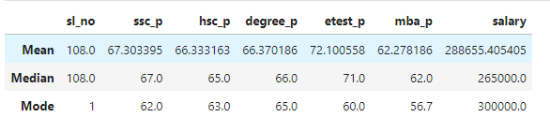

**Placement Dataset Summary Report**

In this report, we will provide an overview of the key statistics (mean, median, and mode) for the different attributes in the placement dataset. These attributes include SSC percentage (10th grade), HSC percentage (12th grade), Degree percentage, E-test percentage (employability test), MBA percentage, and Salary.

1. SSC Percentage (10th Grade)

* Mean: The average SSC score is 67.30%.
* Median: The middle value of the SSC scores is 67%.
* Mode: The most frequently occurring SSC score is 62%.

2. HSC Percentage (12th Grade)

* Mean: The average HSC score is 66.33%.
* Median: The middle value of the HSC scores is 65%.
* Mode: The most frequently occurring HSC score is 63%.

3. Degree Percentage

* Mean: The average Degree percentage is 66.37%.
* Median: The middle value of the Degree percentages is 66%.
* Mode: The most frequently occurring Degree score is 65%.

4. E-test Percentage

* Mean: The average E-test score is 72.10%.
* Median: The middle value of the E-test scores is 71%.
* Mode: The most frequently occurring E-test score is 60%.

5. MBA Percentage

* Mean: The average MBA score is 62.28%.
* Median: The middle value of the MBA scores is 62%.
* Mode: The most frequently occurring MBA score is 56.7%.

6. Salary

* Mean: The average salary offered to students is ₹288,655.
* Median: The middle value of the salaries is ₹265,000.
* Mode: The most frequently offered salary is ₹300,000

**Overall Summary:**

The data reveals that students typically have consistent academic performances across different stages of their education, with percentages hovering around the mid-60s. The employability test results are somewhat higher, indicating better performance in skills-based assessments. The placement salary data suggests that there is a range of salaries offered, with some students earning significantly higher than others, as reflected by the mean being higher than the median.

This report provides a concise overview of the key statistics, offering insights into the general performance and placement outcomes of students in the dataset.